

**ALC functional Requirements**

**Submitted by**

Anshuman Singh

Davide Occello

Raymond Wouters

Sharad Bhadgaonkar

January 19, 2016

-Eindhoven

# CAFCR architecting:

Customer view

Application view

Functional view:

Refer F1

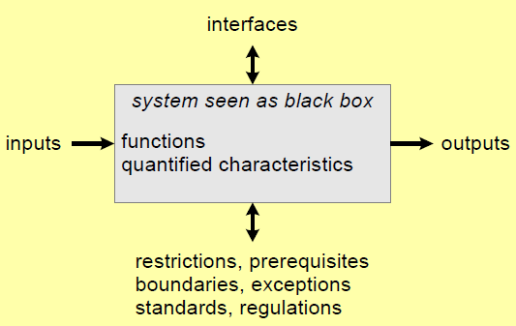

Figure : Black box view

**Functional requirements**

Each customer objective was broken down in a multitude of desired characteristics of the system in the previous phases as can be seen in Figure ??. The following requirements are written in the effort of fulfilling these characteristics.

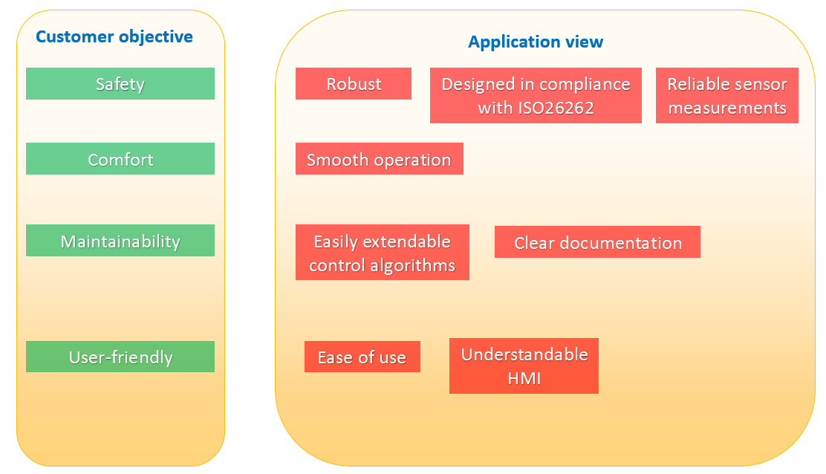

Subscript **F** and **NF** in each requirement are read as functional and nonfunctional requirements respectively.

1. **Safety**
2. **F:** ALC shall be default enabled (ON) at every key cycle once Engine is on.
3. **F:** LCA shall act to keep the vehicle at the center of the lane within a tolerance of 0.15 meters.

Additionally, ALC shall trigger a warning at latest when unintentional lane change is detected. (NEW REQ)

~~Unintentional lane change:~~

~~1. outside of the tire closest to the outside of the lane markings crosses 0.3 m~~

~~2. no turn signal available.~~

~~3. The d~~

1. **F:** The driver shall be able to overrule the system at any point of time.
2. **F:** LCA: LCA shall be deactivated in less than 0.5 second (AVG REng time) when :
   * Manually disabled(off) by the user
   * LCA is active and driver counter steers (opposite to assist torque), with a torque value of more than 0.3 Nm.
   * LCA is active and driver doesn’t intervene to the steering wheel within 5 seconds.
   * Driver activates the Turn signal.
   * Driver brakes (more than 50%).
   * Engine is off
3. **F:** ALC shall warn the driver when driver doesn’t intervene inside 5 seconds when ALC is actively steering the vehicle to the center.
4. **NF:** ALC shall be capable to detect the related component’s functional failure and disable ALC with simultaneous warning to the driver.
5. **NF:** ALC shall warn the driver if the system is disabled by the driver.
6. **F:** (Regulation) LKA system shall be available only if vehicle possess Electronic Stability Control system in compliance with regulatory requirements
7. **F:** (Regulation) ALC shall be operational at least under below conditions while performing unintended lane change.

* Lane width between 3 to 3.7 m
* Dashed line on one side having width of 0.1 to 0.25
* Solid line on other side with 0.1 to 0.25
* Dry weather conditions
* No precipitation
* Horizontal visibility till 1 km
* Ambient temperature between 5 to 40 deg
* Natural ambient illumination excess of 2000 lux for day light with no strong shadow
* Uniform solid paved surface with consistent slope and no irregularity within a lateral distance of 3.0 m to either side. The minimum peak braking coefficient shall be 0.9
* Wind speed less than 10 m/s
* Slope of the surface between 0 and 1 deg
* Original fitment of tires according to make, model, size, speed and load operating specified by the manufacturer with correct pressure.
* Slope of the surface between 0 and 1 deg
* Default wheel alignment measure set by the OEM

1. **F:** (Regulation) The system must have an accuracy of:
   * 0.1 km/h in longitudinal speed
   * 0.03 m in longitudinal and lateral position
   * 0.1 degrees in heading angle
   * 0.1 deg/sec in yaw rate
   * 0.1 m/sec2 in longitudinal acceleration
   * 1 deg/sec in steering wheel velocity
2. **F:** Once disabled (OFF), the ALC can be enabled only if the vehicle speed is ~~less than the minimum speed at which it can be active~~ and the time between OFF and new ON exceeds 1 second.
3. **F:** It shall be possible to disable (OFF) the ALC during runtime, but only when ALC is currently inactive.
4. **NF:** The system shall perform cyclic diagnostic tests on its communication interfaces and HW in order to detect latent faults.
5. **NF**: The system should receive data from the vehicle ECU regarding:
   * Vehicle speed
   * Steering angle
   * Steering torque
   * Yaw rate
   * Longitudinal and lateral accelerations
   * Brake pedal position
   * Steering wheel buttons and levers state
   * Wheel speed information
6. NF: The system should be able to control the following vehicle parameters:
   * the steering wheel angle
   * steering control mode (safe / high performance mode)
7. Comfort
8. **F:** The ALC system shall reduce the workload of the driver by actively steering the vehicle to the center.
9. **F:** The driver must be able to enable/disable the ALC system using a hardware lever/button.
10. **NF:** The switching of control between ALC and the driver shall be smooth.
11. **F:** The steering to counter lateral deviation, shall be in smooth controlled manner and with minimal overshoot.
    * Lateral acceleration < 2 m/s2 while cornering,
    * Lateral acceleration < 0.5 m/s2 while driving straight
    * Lateral jerk < 5 m/s3 overall,
    * Longitudinal deceleration < 3 m/s2
    * If Longitudinal deceleration > 1 m/s2 then, longitudinal speed reduction < 18 km/h
12. **NF:** ALC enable (ON) and disable (OFF) button shall be easily reachable the driver.
13. **NF:** Warning signals shall not distract the Driver.
14. Robust
15. **F:** The ALC system shall be functional only when driving on highways with forward driving speed more than 50 Kph but less than 130 Kph.
16. **NF:** The system shall be able to identify lane markings and lane width according to the country of operation.
17. **F:** LCA shall be operational at least when driving on straight road with radius more than 1000m and 250 m on curved road, unless manually deactivated.
18. **NF:** ALC shall be disabled during below environmental conditions
    * + Uncertainty in lane detection (weather, debris )
      + Temperature range outside the range of -20 and 40 deg Celsius. (** temp of speedgoat 0-50 deg).
      + Driving outside Highways
19. **F:** ~~The effecti…..~~

ALC shall be operational in presence of magnetic or electric fields of magnitude XX.

1. **NF:** The failure warning signal shall be activated and remain activated while the vehicle is being driven and be reactivated after a subsequent ignition off – ignition on cycle as long as the failure exists.
2. **NF:** When the driver is provided with a visual warning signal to indicate that the ALC is temporarily not available, for example due to inclement weather conditions, the signal shall be constant.
3. Maintainability
4. **NF:** It shall be easy to maintain and upgrade the system with additional features e.g. through modul…..
5. **NF:** If needed, ALC shall be able to operate standalone using just the lateral control and necessary sensors and hardware.
6. **NF:** If needed, it shall be possible to interact with other systems in the vehicle like ACC.
7. **NF:** It shall have understandable communication interface. replace
8. User Friendly
9. **NF:** ALC enable/disable lever shall be easily visible to the driver from the sitting position.
10. **NF:** ALC enable/disable lever shall have clear markings for enabling and disabling the ALC system.
11. **NF:** The visual warning signals shall be visible even by daylight and it shall be easily readable by the driver from the driver’s seat.
12. **F:** ALC shall notify the current ALC status using HMI

Status:

Enabled

Active lane centering on

Active LDW (Degraded)

Active lane centering off.

Disabled

1. **F:** The warning provided to the driver shall be noticeable by the driver and be provided

by:

* At least two warning means out of optical, acoustic and haptic, or
* One warning means out of haptic and acoustic, with spatial indication about the direction of unintended drift of the vehicle.